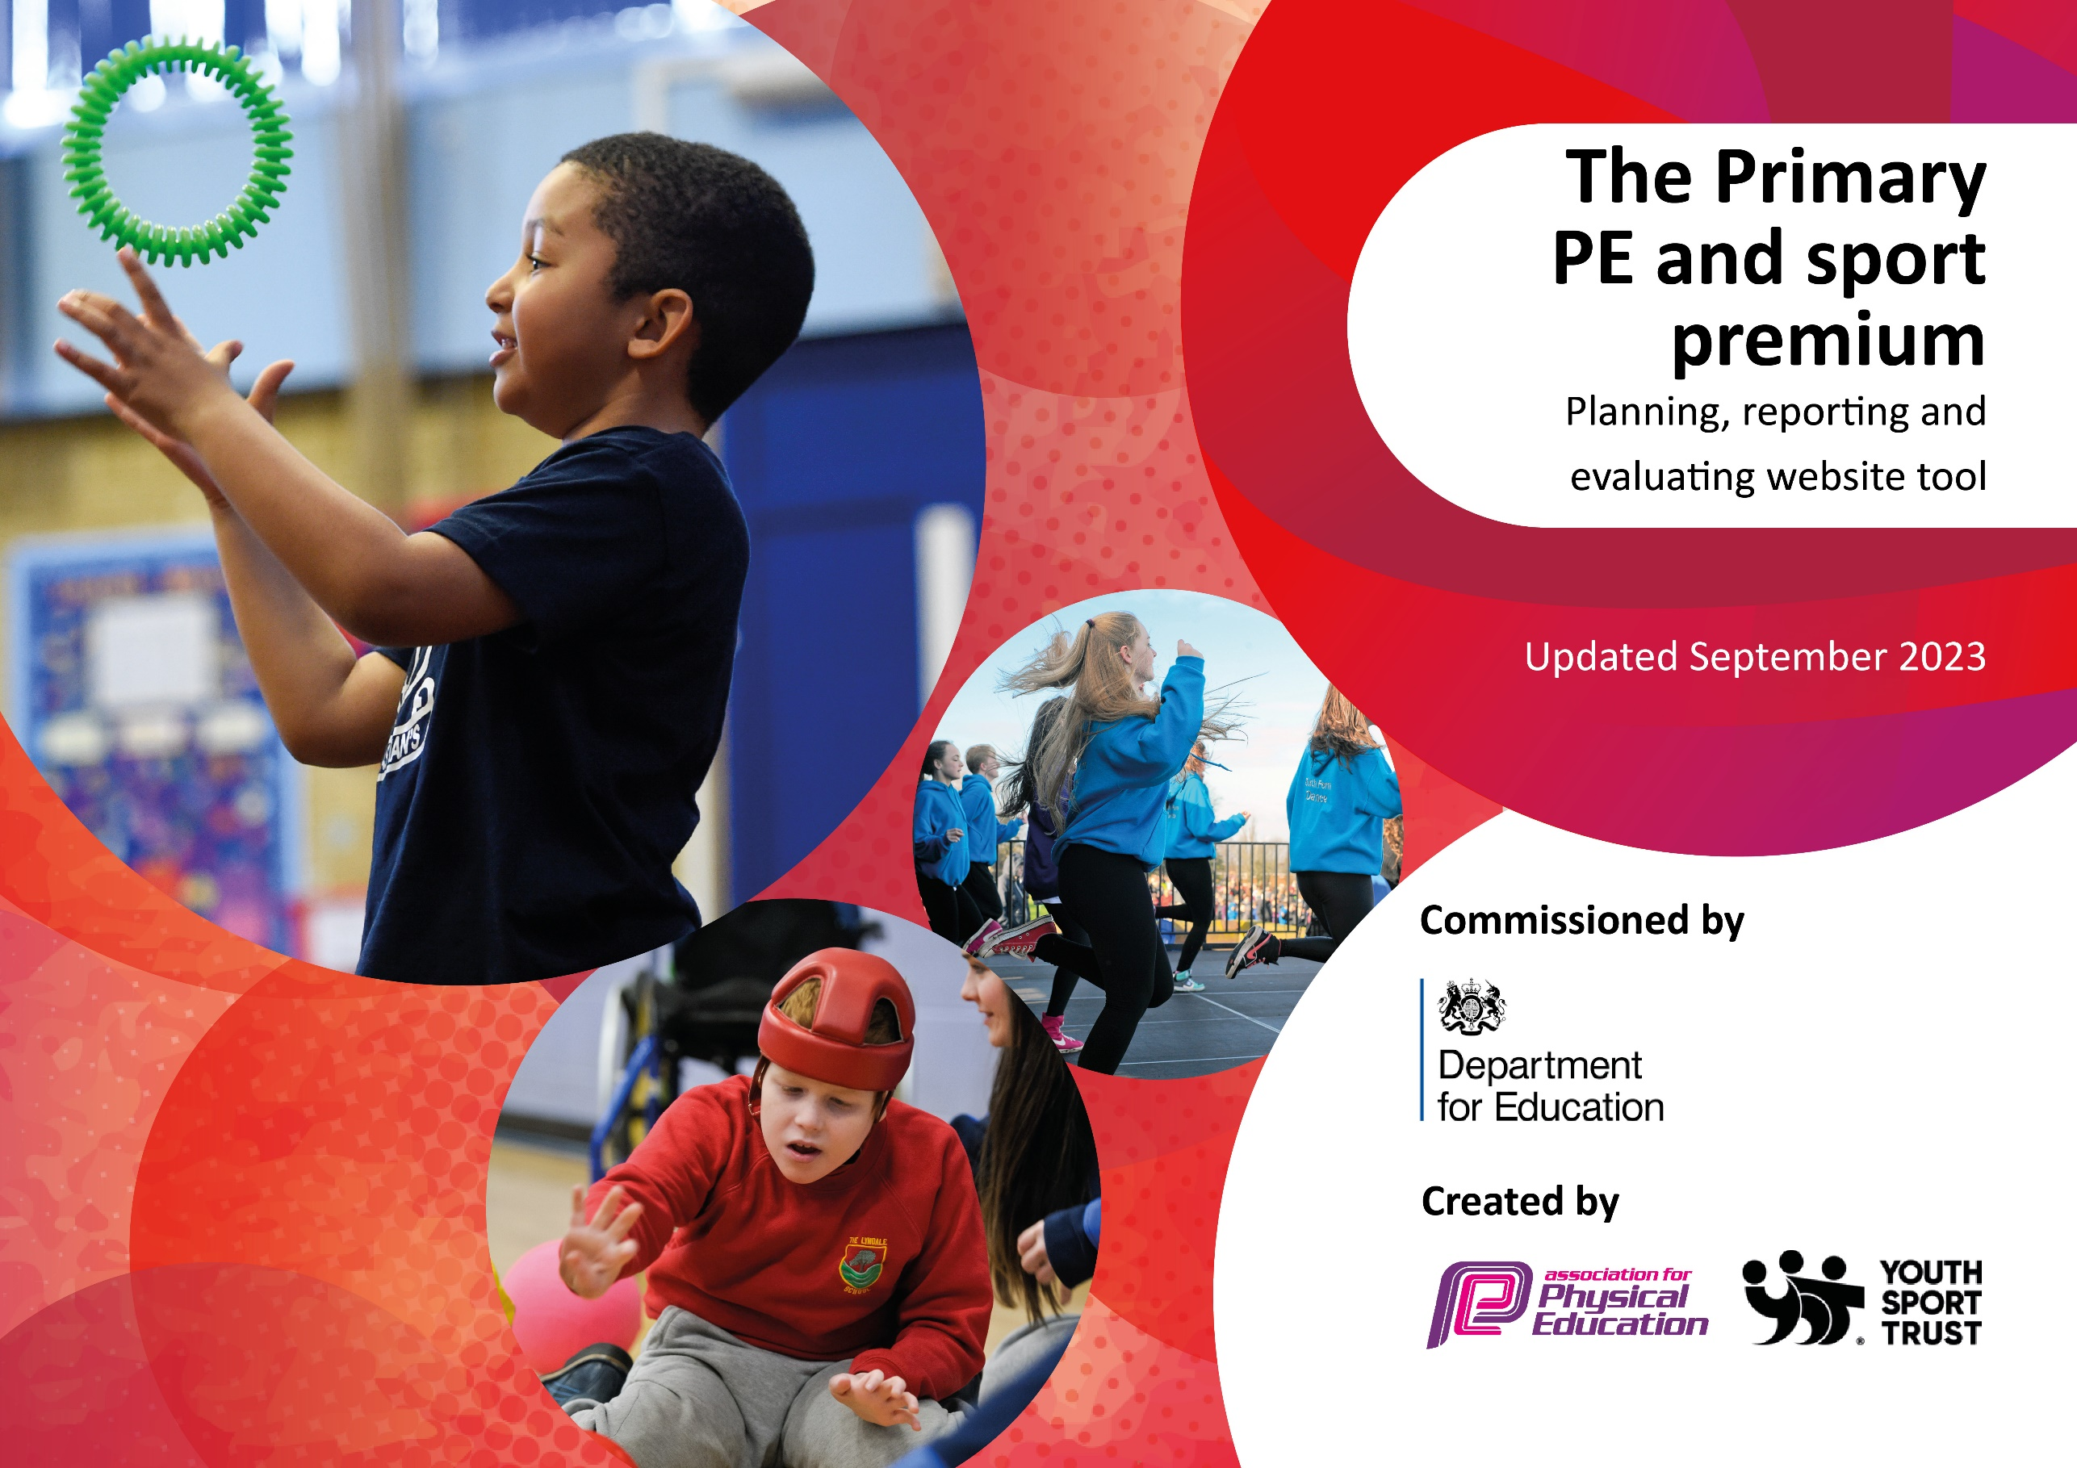

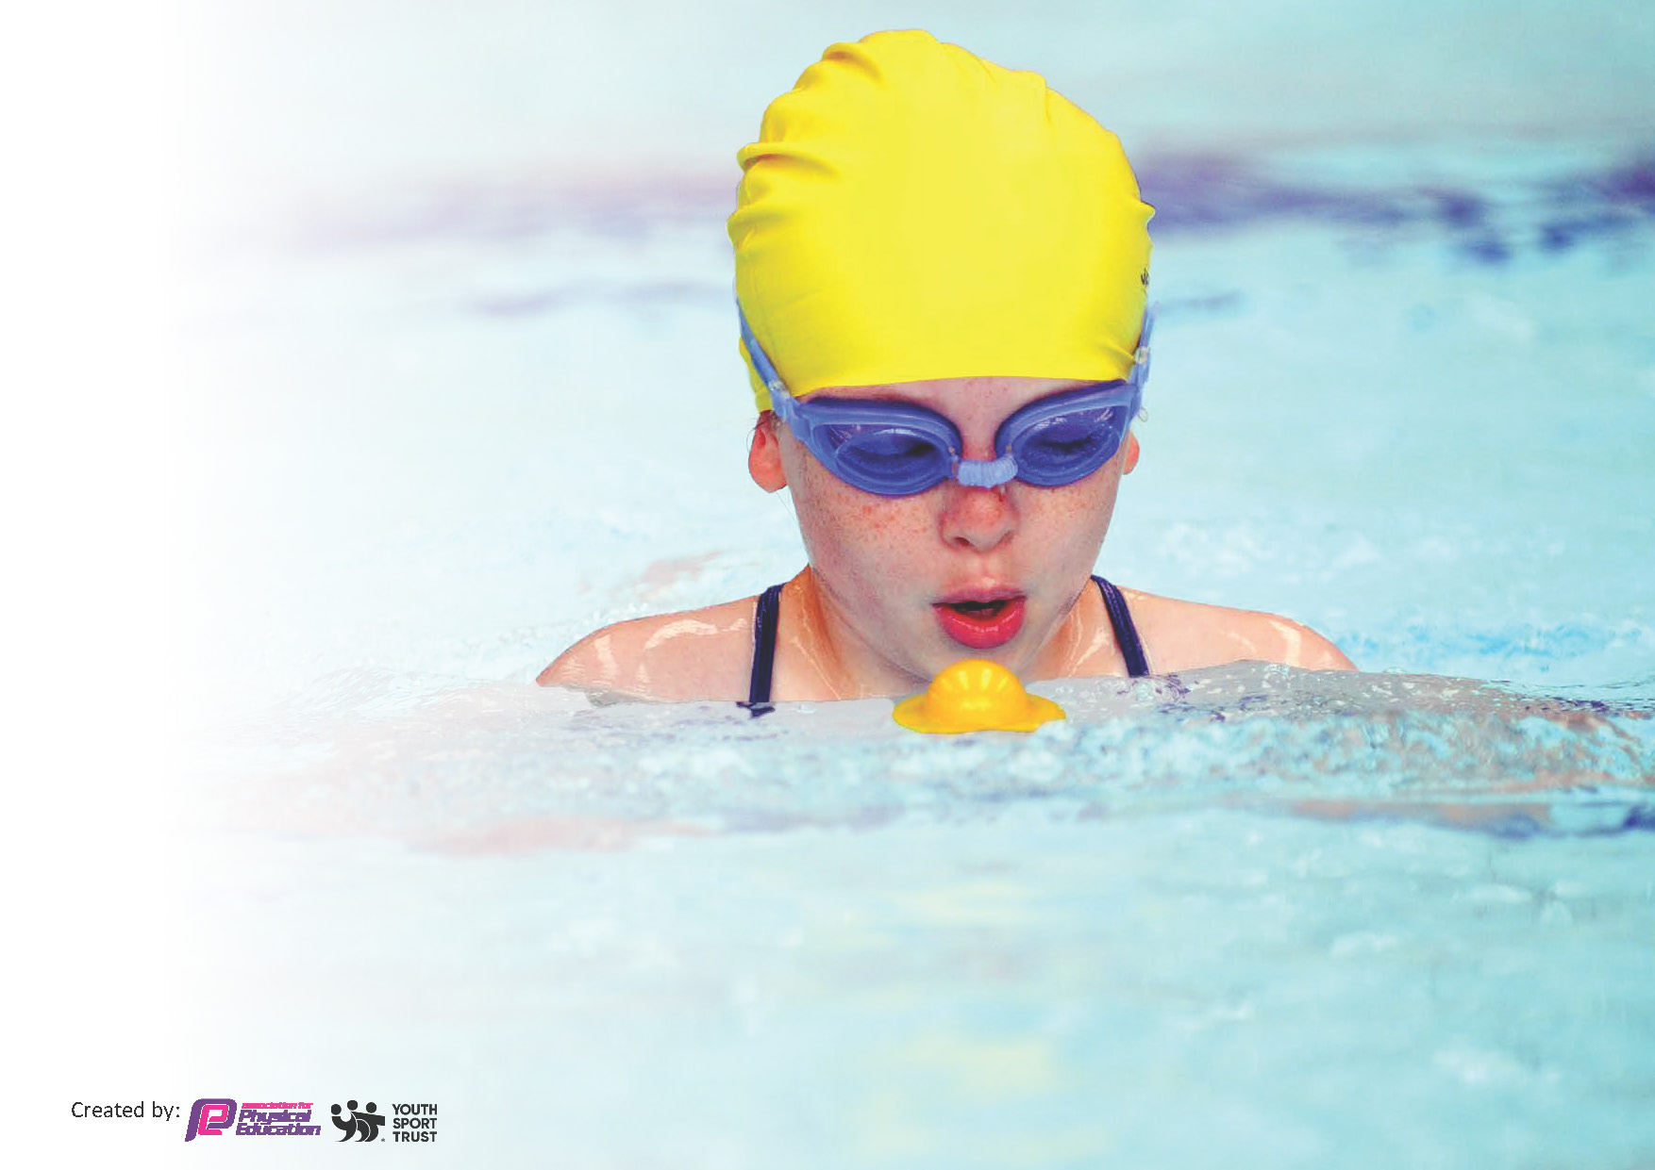
This template can be used for multiple purposes:
by:
- It enables schools to effectively plan their use of the Primary PE and sport premium
- It helps schools to meet the requirements (as set out in guidance) to publish information on their Primary PE and sport premium
- It will be an effective document to support Ofsted inspections enabling schools to evidence progress in Physical Education (PE) and evidence swimming attainment, which forms part of the PE National Curriculum. We would recommend schools consider
the Intent, Implementation and Impact of any spend, as examined within the Education Inspection Framework.

It is important that your grant is used effectively and based on school need.

Schools must use the funding to make additional and sustainable
improvements to the quality of the PE, School Sport and Physical Activity (PESSPA)
they offer. This means that you should use the Primary PE and sport premium to:

- Build capacity and capability within the school to ensure that improvements made now will benefit pupils joining the school in future years
- Develop or add to the PESSPA activities that your school already offers.

The Primary PE and sport premium should not be used to fund capital spend projects; the school’s core budget should fund these. Further detail on capital expenditure can be found in the updated Primary PE and sport premium guidance.

The Primary PE and sport premium guidance, outlines 5 key priorities that funding should be used towards. It is not

necessary that spending has to meet all the key priorities, you should select the priorities that you aim to use any funding towards.

Although completing this template is not a requirement for schools, schools are required to publish details of how they spend this funding. Schools must also outline what the impact this funding has had on pupils’ PE and sport participation and attainment and how any spending will be sustainable in the future. All funding must be spent by 31st July 2024.

The Department for Education has worked closely with the Association for Physical Education (afPE) and the Youth Sport Trust (YST) to develop this template and encourages schools to use it. This template is an effective way of meeting the reporting requirements of the Primary PE and sport premium.
Review of last year’s spend and key achievements (2022/2023)

St Patrick’s and St Edmunds Catholic Primary School now receives £16,000 plus an additional £10 per pupil (from Y1 to Y6), this equates to roughly £19,180 (TBC) for the academic year 2023/24. This is subject to change as we are a newly opened school following an amalgamation with St Edmund’s Catholic Primary (Now Closed) This figure is based on our current school pupil figures and will amended accordingly when the DFE publish our allocation.
The purpose of this funding is to ensure that sport and PE provision addresses the needs of all pupils, including those who belong to disadvantaged, vulnerable and gifted groups. Please see our Sports Premium Spending Strategy below for more details.

We recommend you start by reflecting on the impact of current provision and reviewing your previous spend.

Activity/Action | Impact | Comments
- Developing the range of extra-curricular activities  - OAA Residential Coordinating a weekend residential for Year 6 In October 2022 at venues in Cromer (Overstrand) In2Action  - Develop the curriculum to develop physical activity through 2 quality PE lessons a week  - To offer a broad range of sports and competitions relevant to our pupils  - Further develop the subject knowledge and skills of our teachers through CPD  - To make PE and school sport inclusive and accessible for all SEND Children.  - To provide school swimming sessions for 63% of our school children (Yr2-Yr6) to embed self-water rescue, water confidence & swim 25m  - Create community links with local sports club | - 67% Children are physically active after school and have access to clubs and throughout the academic year.  - 98% of our year 6 children went away for the weekend and took part in OAA activities and benefited hugely from this life experience.  - 100% of our pupils are offered a wide cohesive and progressive curriculum that enables all of our pupils to develop and extend their physical development and education.  - We have gained our School Games Gold mark for 22/23 & Pathway 2 Podium Silver Award for excellent provision for Competition  - 1-1 co leading PE sessions with professional coaches and PE Lead. CPD sessions taking place with all classes throughout the academic year. Minimum of a half term per class teacher and sessions to cover a particular area or topic of PE to strengthen teacher weaknesses and subject knowledge.  - SEND Children are now accessing PE lessons using sensory equipment to support the children’s development of fine and gross motor skills and also to help manage their behavior.  - 57% of Year 6 children left school in the summer (July 2023) with being able to swim a minimum of 25m and perform self-water rescue.  - Having built a relationship with Warwickshire County Cricket, this provided a pathway for 33% of our club children to attend an out of school club cricket at Handsworth CC. | - All children have the opportunity to take part in competitive sport through our competition Calendar. We run inter house competitions during PE lessons along with a ‘personal best challenges’ where everyone has the chance to beat their own scores as well as being competitive against others. As a school, we are part of the Caritas Christi in Urbe Catholic school group, Hamstead Hall School Games Partnership, Birmingham Catholic School Sport Association and Aston Schools Football which provides many additional opportunities for our children

Key priorities and Planning
This planning template will allow schools to accurately plan their spending.

Action – what are you planning to do | Who does this action impact? | Key indicator to meet | Impacts and how sustainability will be achieved? | Cost linked to the action
Purchase of new PE Sports Equipment for both KS1 & KS2  SEND Sensory Equipment for NEST Unit  Playground Sports Equipment  OAA Residential  Coordinating a weekend residential for Year 6 In October 2023  Additional Intensive Top Up Swimming (Whole School KS1 & KS2)  To include Sensory Swim sessions for NEST 1hr per week  Leadership and Sports Leadership  For upper KS2 (Yr4,5 and 6). | More children being active through the use of the equipment during all aspects of activities.  More pupil’s active and developing life skills and experiencing activities that they would not normally having had the chance of taking part in, especially being from a deprived ward of Birmingham.  The benefits of social, Health and mental wellbeing for our children, whilst improving behavior and class moral.  This is to really to reintroduce the importance of swimming being a much need life skill and for all our children to catch up on valuable swimming lessons that they have missed out on during the Covid-19 pandemic.  • Our current Year 6 will hopefully leave school with being able to swim a minimum of 25 Metres and perform self-water rescue.  Increase the confidence of our young pupils to deliver playground games and play lead their own class activities and games with friends. | Key indicator 1: The engagement of all pupils in regular physical activity – Chief Medical Officers guidelines recommend that primary school pupils undertake at least 30 minutes of physical activity a day in school  -Purchase appropriate sport equipment to assist with lessons, PPA after school care and with our more challenging SEND children  Key indicator 1: Increase the range of activities available in order to give pupils a broader experience of outdoor pursuits.  - See Pupil Voice feedback sheets  Key Indicator 1: The aim is for this to take place throughout the year at Harborne Baths.  A1:Yr6-A2:Yr6  SP1: Yr5- SP2: Yr5 & Yr2  SUM1: Yr4- SUM2: Yr3  Weekly Swim Sessions: Friday’s: NEST  Key indicator 2: The profile of PESSPA being raised across the school as a tool for whole school improvement  For each whole class in KS2 to develop as Playground leaders or young officials, to organise and run their own playtimes. Teachers and Lunch timer supervisors to offer support.  As Highlighted as an action point from the Pathway to Podium self-assessment tool Autumn 2023-24 | Extra Equipment purchased in order to replenish class stock if broken or lost to ensure active playtimes.  Equipment reviewed regularly and upgraded when needed to maintain high quality delivery for lessons using the correct primary based sports equipment.  School committed to continue annually from school fund in order to subsidize for our most vulnerable families.  -This is to really to reintroduce the importance of swimming being a much needed life skill  Our current Year 6 will hopefully leave school with being able to swim a minimum of 25 Metres and perform self-water rescue.  -School committed to continue annually from school fund in order to fund addition transport for two year groups to go at the same time like in previous years  -Plus, the additional support for free funded lessons from Swim England for Yr2’s to complete 3x1hour water safety course  Will continue through behaviour incentives and G2BG with Staff SL/LS. | £3000  £3000  (Completed 13th-16th Oct 2023) 86% of our year 6 children went away for the weekend  Kingswood ‘Staffordshire, Albrighton’ Residential In2Action  £4000  Projected  £50 Per Class x6 (£300)

Health for Life – whole school development (2023-24)  -Parental Engagement (Inspire Workshop)  -Active 60  Staff CPD  -upskilling all staff through CPD co-lead PE sessions with a coach to promote teacher and school development.  - (Whole School Staff Meeting)  -Online Teams Courses around both Staff and Children’s Physical/Mental Health and Well Being.  -All teaching staff to run an after school club of their choosing (CPD)  After School Sports Provision and Clubs  Introduce further sporting opportunities and offer children the chance to represent the school at competitions. | Delivered through PE Lessons, lunch / Play times and also class room based learning such as PATHS, Science and PHSE. Covered in the new curriculum of ‘Building the Kingdom’  Greater subject knowledge of staff through observations and teacher feedback  Greater understanding of the importance of Physical/mental health and wellbeing, both from a personal perspective and from the experiences our children go through. Especially since the nationwide lockdowns due to the pandemic and within the school recovery curriculum.  For more children in school to experience and participate in an active sports club  Children Being active and used for talent ID in their PE sessions  Clubs  •Multi Skills (Fit and Active Club) EYFS, KS1, (Least Active / Pupil Premium)  •Multi Sports (Fit and Active) KS2  •Netball / Basketball KS2  •Boys’ and Girls’ Football Club  •Cricket Club  •Athletics Club  School Games Jennifer Ratcliffe (SGO (St. John Wall Catholic School)  Aston Schools Football Association  Birmingham Catholic School Sports Association (Additional Competitions in Basketball and Cricket)  Caritas Christi in Urbe Sports (Inclusive Boccia and New Age Kurling Festivals for our SEND & Least Active Children)  Cross Country  Girls Football  Swimming Gala  Tag Rugby Festival  Athletics | Key Indicator 2: To continue to embed an understanding for our children and parents to achieve lifelong active and healthy lifestyles.  As Highlighted as an action point from the Pathway to Podium self-assessment tool 2023-24  Key Indicator 3: Identifying and choosing the correct staff to attend courses to aid teacher development for the benefit of delivering their own PE Lessons.  Key Indicator 3: Identifying and choosing the correct courses to aid teacher and pupil development.  Key Indicator 3: For staff to run a club for at least a full term for their class as a part of their own professional development  Key Indicator 4: Broader experience of a range of sports and activities offered to all pupils  Key Indicator 4: These sessions offer all of our children to take part in a variety of fun, structured activities which we hope will increase their confidence to perform, but also to target extra physical activity.  Key Indicator 4: The improvement of children’s behaviour and life skills / experience through sport.  Key Indicator 4: NQT’s and teachers delivering sports clubs, to allow children to be taught by a wide range of school teachers.  Key Indicator 5: Increased participation in competitive sport  Key Indicator 5: Our Level 2 competition calendar offers and fulfils all of our participation figures for an academic year.  Key Indicator 5: Our competition list allows our children to experience and compete against neighboring schools.  -Networking, Resources, Guidance and Activities  Key Indicator 5: Promoting our children to do their personal best and push/challenge themselves in all areas of sport and competition in and outside of school in order to achieve and succeed.  Key Indicator 5: Attend a Level 3 City games | Continually linked to all aspects of the curriculum  Nature Friendly Schools to help run projects and to facilitate trips to broach the subject of leading physical and active lives outdoors.  Staff becoming more qualified and confident in their own delivery of PE and sport  Staff becoming more self-aware and understanding signals of stress and anxiety, with coping strategies in hand to help deal with both personal and work life pressures.  For Staff to recognize when children maybe experiencing tough times or anxieties and be competent enough to deal with them appropriately.  For teachers to run more clubs instead of paid coaches and staff to take charge of teams such as football, netball and Basketball  funding spent on 1-1 co leading PE sessions with professional coaches and PE Lead. CPD sessions taking place with all classes throughout the academic year.  Minimum of a half term per class teacher and sessions to cover a particular area or topic of PE to strengthen teacher weaknesses and subject knowledge.  Teachers to take an active role in the delivery of clubs to support SDP and school life.  Becomes sustainable by teachers delivering regular clubs through improved subject knowledge and this allows for more frequent clubs to take place, lowering the cost of have an external supplier to deliver.  To be Implemented into all aspects of PE and Sport throughout school, which ties into the curriculum map and allows children to be prepared for a competition.  Teachers to take a proactive role in offering internal (Intra Comps- Level 1) that tie in with the topic they have been delivering to their class. | £200  Projected  £6,000  Projected  £1500  £1180  Projected  Total Spend  for 2023-24  £19,180

Key achievements 2023-2024
This template will be completed at the end of the academic year and will showcase the key achievements schools have made with their Primary PE and sport premium spending.

Activity/Action | Impact | Comments

Swimming Data
Meeting National Curriculum requirements for swimming and water safety.
Priority should always be given to ensuring that pupils can perform safe self-rescue even if they do not fully meet the first two requirements of the National Curriculum programme of study

Question | Stats: | Further context  Relative to local challenges
What percentage of your current Year 6 cohort can swim competently, confidently and proficiently over a distance of at least 25 metres? | 44% | A large majority of our children do not know how to swim and have never had external swimming lessons, the school swimming provision provided by our school is the only experience that they receive. So many of our children start by securing skills in basic water confidence and understanding about safety in the water and being able to perform self-water rescue.  All Classes have a minimum of 5 weeks and Year 6 and Year 5 have a minimum of 12 weeks in the pool.  The swim teachers at Harborne Baths are extremely knowledgeable and patient and even offer an in the pool instruction service, if required which really helps our children progress quickly.
What percentage of your current Year 6 cohort can use a range of strokes effectively [for example, front crawl, backstroke, and breaststroke]? | 26%  8% (Stage 7 Swimmers) | Most of the children can swim between 20-25m unaided using the main two strokes (front and Back)  The 2 stage 7 swimmers also support the weaker swimmers in a young coaching/support role which allows them to demonstrate and aid the children in develop their technique.

What percentage of your current Year 6 cohort are able to perform safe self-rescue in different water-based situations? | 44% | The first 3 lessons are all based around self-water rescue which covers aspects of safety around water and specific floating techniques.  -Guidance followed by Swim England
If your schools swimming data is below national expectation, you can choose to use the Primary PE and sport premium to provide additional top-up sessions for those pupils that did not meet National Curriculum  requirements after the completion of core lessons. Have you done this? | Yes | After the Yr6 swimming Assessment in December, any child that has not met the national targets, top up swimming will be taken in July 2024.
Have you provided CPD to improve the knowledge and confidence of staff to be able to teach swimming and water safety? | Yes | All of our teaching staff who attend swimming with their classes all have access to opportunities to shadow the swim coaching staff and develop their subject knowledge, in order to deliver basic swim lessons, including water safety if the coach happens to be away or absent.

Signed off by:

Head Teacher: | Kathryn Cairns (Head)
Subject Leader or the individual responsible for the Primary PE and sport premium: | Lee Fraser (Head of PE & Sport)
Governor: | Maja Szeliga (Chair)  Debbie Johnson (Associate Governor)
Date: | 15th November 2023 (Working Document)

